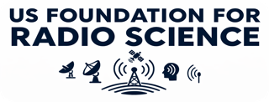
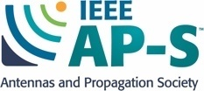
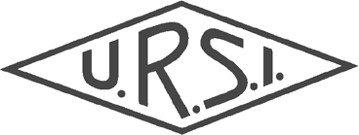

National Radio Science Meeting

53rd Anniversary Event
January 5 – 8, 2027 at the Limelight Hotel in Boulder, CO: www.nrsmboulder.org
USNC-URSI website: http://www.usnc-ursi.org/

You are cordially invited to the in-person 2027 National Radio Science Meeting (NRSM). This meeting is sponsored by the U.S. National Committee (USNC) for the International Union of Radio Science (URSI), and it is technically co-sponsored by the IEEE Antennas and Propagation Society. The 2027 NRSM will include scientific sessions, a plenary session, an invited Hans Liebe Lecture, commission meetings, workshops / short courses, exhibits, a Women in Radio Science (WIRS) reception, a student paper competition, and a student mentoring luncheon. We look forward to seeing you in Boulder, CO in January!
USNC-URSI Chair (2024 – 2026): Jamesina J. Simpson, jamesina.simpson@utah.edu
USNC-URSI Chair-Elect (2024 – 2026): Chris Anderson, canderson@ntia.gov
USNC-URSI Chair-Elect (2027 – 2029): Branislav Notaros, notaros@colostate.edu
USNC-URSI Immediate Past Chair (2024 – 2026): Michael Newkirk, Michael.Newkirk@jhuapl.edu

ABSTRACT AND SUM MARY SUBMISSIONS
Abstract and summary preparation and submission instructions are posted. Authors have their choice of submitting one-page abstracts or two-page summaries, both of which may be archived in IEEE Xplore if desired by the authors. Abstracts must have a minimum of 250 words and summaries are limited to two pages. The deadline to submit is Friday, September 11, 2026. In order for an abstract / summary to be included in the proceedings and submitted to IEEE Xplore, at least one author must be registered and the corresponding presentation must be delivered in person. Registration is also required to attend any session of the meeting.

Abstracts or summaries on any topic relating to the ten Commissions listed below are welcome. Special sessions are being organized and are listed on the conference site. Contact the appropriate USNC-URSI Commission Chair listed below or visit the Topics page on the meeting website for a list of topics and special sessions.

COMMISSIONS
A: Electromagnetic Metrology  Chair: Matthew Simons; matthew.simons@nist.gov | F: Wave Propagation and Remote Sensing  Chair: David Kunkee; david.kunkee@aero.org
B: Fields and Waves  Chair: Reyhan Baktur; reyhan.baktur@usu.edu | G: Ionospheric Radio and Propagation  Chair: Thomas Gaussiran II; gauss@utexas.edu
C: Radio-Communication Systems and Signal Processing  Chair: Eric Mokole; ericmokole@outlook.com | H: Waves in Plasmas  Chair: Chris Crabtree; chris.crabtree@nrl.navy.mil
D: Electronics and Photonics  Chair: Jonathan Chisum; jchisum@nd.edu | J: Radio Astronomy  Chair: Bryan Butler; bbutler@nrao.edu
E: Electromagnetic Environment and Interference  Chair: Charles Dietlein; cdietlein@ntia.gov | K: Electromagnetics in Biology and Medicine  Chair: Sima Noghanian; sima_noghanian@ieee.org

STUDENT TRAVEL SUPPORT
Travel support is available for students.

ERNEST K. SMITH USNC-URSI STUDENT PAPER COM PETITION

Prizes are available: First Prize in the amount of $1000, Second Prize $750, and Third Prize $500. The deadline for students to submit to this competition is also Friday, September 11, 2026. This deadline will not be extended.
Questions?
For questions concerning conference logistics, please contact Christina Patarino at:
Phone: (303) 492-5151
E-mail: nrsmboulder@colorado.edu
Abstract / Summary Submissions and Student Paper Competition Submissions are due by
September 11, 2026
Please visit www.nrsmboulder.org

